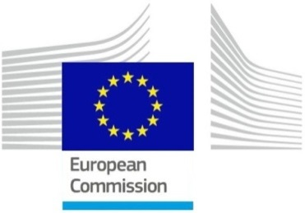 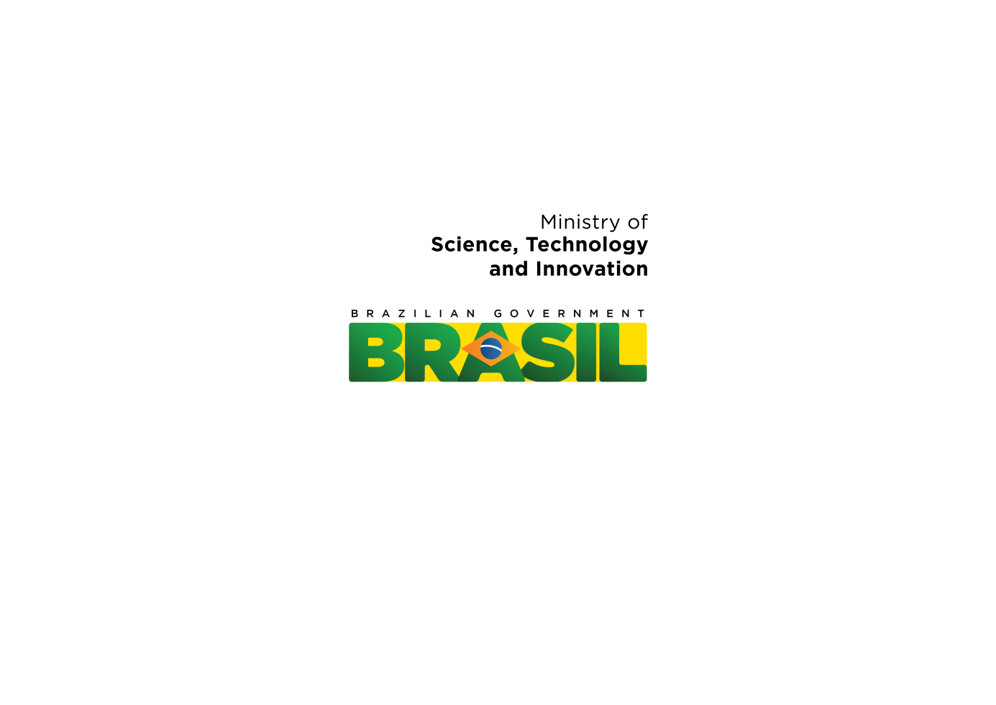

**Draft PROGRAMME**

**High Level Meeting**

**EU-Brazil Atlantic Ocean Research Cooperation**

***16 and 17 November 2015,***

***Rio de Janeiro, Brazil***

**Objective**

The objective of this event is to develop common expertise and scientific knowledge on the Atlantic Ocean and its dynamic systems, to discuss how to further engage in joint research projects and improve reciprocal access to infrastructures and to provide a new momentum for enhancing marine cooperation between Brazil and Europe.

**Outline**

**Day 1** – Scientific Workshop

The Atlantic Ocean constitutes a broad suite of challenges for both Brazil and Europe. In order to tackle them the following scientific requirements for better understanding and implementing activities on the following key issues will guide the discussions:

* Ecosystem approach
* Assessing and responding to climate change impacts;
* Reducing uncertainties through integrated observing systems;
* Improving safety at sea, human health and well-being;
* Setting up a standardisation procedure for sampling protocols, data access and use and
* Identifying new and emerging technologies to service societal needs.

**Day 2** will include

* Report from the South-South Workshop on the Tropical and South Atlantic Research Collaboration, Capes – Brasília-DF, 21 - 22 October 2015;
* Presentation on the outputs and recommendations of the Day 1 Scientific Workshop;
* A Roundtable discussion about enhancing Brazil-Europe cooperation
* Key note address from Carlos Moedas Commissioner for Research, Innovation and Science and Celso Pansera Minister of Science, Technology and Innovation and signing ceremony of a Declaration of Intend for enhanced marine cooperation
* Testimonials from participants in the Science without Borders Programme and examples of successful ongoing Brazil-Europe cooperation initiatives.

**Participants / Stakeholders**

High Level political representatives from Brazil and the European Commission; Leading Scientists, Representatives from Marine and Oceanographic Institutes, Funding Agencies, Research Performing Organisations and Industry

**Organisers**

This conference is organised jointly by:

* The Ministry of Science, Technology and Innovation of the Federative Republic of Brazil (MCTI), Brazil National Academy of Science and COPPE Instituto Alberto Luiz Coimbra de Pós-Graduação e Pesquisa de Engenharia.
* The European Commission and the European Delegation to Brazil together with Representatives from France, Germany, Ireland, Italy, , Portugal, Spain, etc

**Conference Venue**

*National Academy of Science (16 and 17 November),*

*Rio de Janeiro, Brasil*

***DRAFT PROGRAMME***

***EU-Brazil Atlantic Ocean Research Cooperation***

**Rio de Janeiro, 16 and 17 November 2015**

***Scientific Workshop***

**Aims & Objectives:**

**Key Questions to be answered**:

1. What are common (Brazil- Europe) knowledge gaps where co-operative research efforts are needed?
2. How can we (Brazil- Europe) better share knowledge on existing activities, projects or systems already in place and how can connectivity between on-going knowledge generation be assured?
3. How to foster joint (Brazil- Europe) access to existing knowledge to maximise its exploitation and impact (e.g. access to data, needs for data exchange and standards, etc)?
4. How to promote Brazil-Europe-Brazil mobility and training so as to establish lasting cooperation partnerships?

**Output:**

Workshop Report summarising and making recommendations regarding:

* Knowledge gaps identified and recommendations to deal with them jointly;
* Ways to maximise sharing of existing knowledge (or of knowledge being generated);
* Ways to support joint access to existing knowledge to maximise its exploitation and impact.

***DRAFT PROGRAMME***

***EU-Brazil Atlantic Ocean Research Cooperation***

|  |  |  |
| --- | --- | --- |
| ***Day 1 - Scientific Workshop***  **Monday, 16th of November 2015, Rio de Janeiro** | | |
| **09:00 – 09:30** | **REGISTRATION** |
| **09:30 – 09:40** | **Introduction: Aims & Objectives**  Brazilian and European speaker |
| **09:40 – 10:15** | **Report from the *South-South Workshop on the Tropical and South Atlantic Research Collaboration*, Capes – Brasília-DF, 21 - 22 October 2015**  **Identification of Key Challenges**  Brazilian and European speaker |
| **10:15 – 11:00** | **Session 1: Transatlantic Ocean Observation and Forecasting Systems**  **Chair: Leticia Cunha (tbc)**  **Brazil**:   * **Janice Trotte (SecCTM)** * **Moacyr Araujo (UFPE)**   **Europe**:   * **Peter Brandt (GEOMAR, DE)** * **Jacques Populus (IFREMER, FR)**   **Questions & Answers** |
| **11:00 – 11:30** | **COFFEE BREAK** |
| **11:30 – 12:15** | **Session 2: Food security (including aquaculture)**  **Chair: Ulrich Saint-Paul (tbc) Carlos Magno (tbc)**  **Brazil:**   * **Rodrigo Roubach (MPA)** * **Ronaldo Cavalli (UFRPE)**   **Europe:**   * **Patrick Sorgeloos (European Technology Platform Aquaculture and University of Ghent, BE)** * **Jean Prou (IFREMER)**   **Questions & Answers** |
| **12:15 – 13:00** | **Session 3: Innovative use and conservation of the Atlantic biodiversity (including biotechnology)**  **Chair: Fabiano Thompson**  **Brazil:**   * **Andre Lima (UNIVALI)** * **Carlos Magno (EMBRAPA)**   **Europe:**   * **Isabel Sousa Pinto (CIMAR, PT)** * **Martin Zimmer, (Leibniz- Centre for Tropical Marine Ecology, DE)**   **Questions & Answers** |
| **13:00 – 14:00** | **LUNCH** |
| **14:00 – 14:45** | **Session 4: Land-sea interactions**  **Chair: Ulrich Glasmacher Rapporteur: Peter Hackspacher**  **Brazil:**   * **Vanessa Hajte (UFBA)** * **Carlos Rezende (UENF)**   **Europe:**   * **Carlos Garcia-Soto (IEO-Spanish Oceanographic Institute)** * **Stefan Mulitza (MARUM, DE)**   **Questions & Answers** |
| **14:45 – 15:30** | **Session 5: Ocean technology**  **Chair : Janice Trotte (tbc)**  **Brazil:**   * **Carlos Parente (COPPE)** * **Segen Estefen (COPPE)**   **Europe:**   * **José Joaquín Hernández-Brito (PLOCAN, ES)** * **Peter Heffernan (Marine Institute Galway, IRL)**   **Questions & Answers** |
| **15:30 – 16:15** | **Session 6: Ocean literacy**  **Chair : tbc**  **Brazil:**   * **Danilo Koetz de Calazans (FURG)** * **Cintia Miyaji (UNIMONTE)**   **Europe:**   * **Ana Noronha (SeaChange and AORAC, H2020 Projects, PT)** * **Isabel Sousa Pinto (CIMAR, PT)**   **Questions & Answers** |
| **16:15 – 16:30** | **Joint Programme Initiative Healthy and Productive Oceans: opportunities for international cooperation, Gilles Lericolais, FR** |
| **16:30 – 18:00** | **Conclusions: Prepare Workshop Summary and Recommendations** Presented by Chairs followed by Discussion |
| **18:00** | **Networking cocktail for workshop participants** |

***DRAFT PROGRAMME***

***EU-Brazil Atlantic Ocean Research Cooperation***

|  |  |
| --- | --- |
| **Tuesday , 17th of November 2015, Rio de Janeiro**  **Plenary session - morning** | |
| **09:30 – 10:00** | **Registration** |
| **10:00 – 10:45**  **(45 min)** | **Promote mobility and build long lasting partnerships:**   * **Carla Salvaterra, University of Bologna and Italian coordinator for the *Brazilian Science Without Border Programme*** * **Speaker from CAPES (tbc)** * **Brazilian testimonials from the *Science Without Borders Programme*** |
| **10:45 – 11:00** | **Group Picture** |
| **11:00 – 11:30**  **(30 min)** | **Report on the joint EU-Brazil research activities**  **Brazil: Jailson Bittencourt de Andrade (tbc)**  **Europe: John Bell**  **Report on the Recommendations from the Scientific Workshop on Day 1**  **Brazil: TBD**  **Europe: Michael Schulz, MARUM DE** |
| **11:30 – 12:00**  **(30 min)** | **Keynote addresses by:**   * **Celso Pansera Minister of Science, Technology and Innovation of Brazil** * **Carlos Moedas, European Commissioner for Research, Innovation and Science**   ***Followed by the signing ceremony*** |
| **12:00 – 13:00** | **light lunch break** |
| **13:00 – 15:00**  **(120 min)** | **Showcasing examples of bilateral Atlantic Cooperation Activities**   * **Ocean Tracking Network, Pedro Afonso and José Muelbert** * **Bilateral project with GEOMAR, Letícia Cunha** * **GEOTRACES, Vanessa Hatje** * **Brazil-Spanish- Cooperation Activities, Carlos Garcia-Soto, IEO-Spanish Oceanographic Institute ES** * **PIRATA Initiative, Moacyr Araujo** * **Brazil-Portugal Cooperation Activities, Jorge Oliveira e Carmo, PT** * **Brazil-Italy Cooperation, Carla Salvaterra, University of Bologna, IT** * **Brazil-Belgium Cooperation Activities, Patrick Sorgeloos, University of Ghent, BE** * **Others….** |
| **15:00 – 15:30** | **Coffee break** |
| **15:30 – 16:45** | **Panel discussion: Insights from the conference and next steps** |
| **16:45-17:00** | **Closing remarks: Jailson Bittencourt de Andrade (tbc) and John Bell, European Commission** |